Homework 1

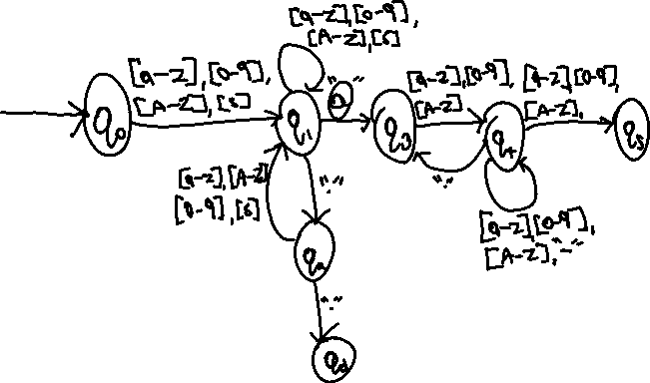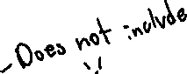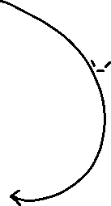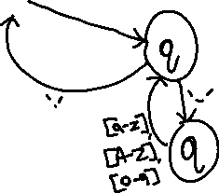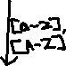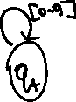

2. / ([A-Z][a-z][0-9][s])(([A-Z][a-z][0-9][s])+)([A-Z][a-z][0-9][s])(@) /

[s] does not include ‘.’ In this case as well. Period is on the side.

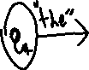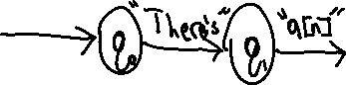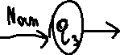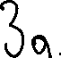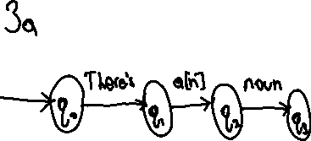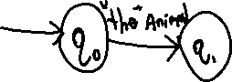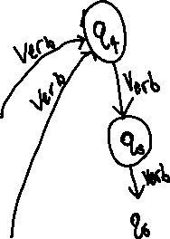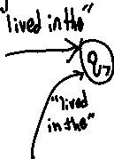

3c. It would be possible to design an FSA that would work to arbitrary depth n if there was not a limit set. The difference between part A and part B is that part A does not have a limit on the number of nouns used, but in part B, the limit only allows it to go to a predetermined number. This means that an infinite loop can be done in part A, but in part B, a way to count the amount of times done is needed to ensure the limit is not surpassed.

